|  |  |
| --- | --- |
| Ex.No.12a | **SIMULATION OF VPN USING CISCO PACKET TRACER** |

**AIM:**

To practice or simulate VPN using Cisco Packet Tracer.

**DESCRIPTION:**

**What isVPN?**

A VPN (Virtual Private Network) is a technology that creates a secure, encrypted connection over a less secure network (like the internet) by tunneling your data. It allows users to access the internet or private networks securely and privately.

**Usage of VPN in Network Management:**

VPN allows employees to securely connect to the company's internal network from remote locations. It encrypts data to protect it from unauthorized access while in transit. Network administrators use VPNs to control which users can access network resources. Additionally, VPN can help prioritize traffic, improve network performance, and optimize bandwidth usage.

**What is the functionality of VPN?**

VPN encrypts data before sending it over the internet to ensure confidentiality. It

encapsulates data in a private tunnel to hide it from third parties. It also masks the user’s IP address to maintain privacy and provides secure access to internal network resources over the internet.

**SCREEN SHOTS:**

**Step 1 :**

Arrangement of Routers and PCs.

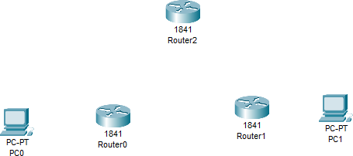

**Step 2 :**

Connection establishment using wires.

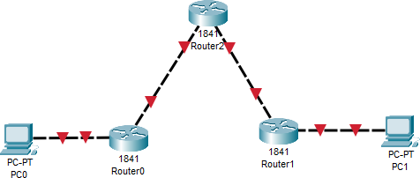

**Step 3 :**

Assigning IP address for Routers and PCs.

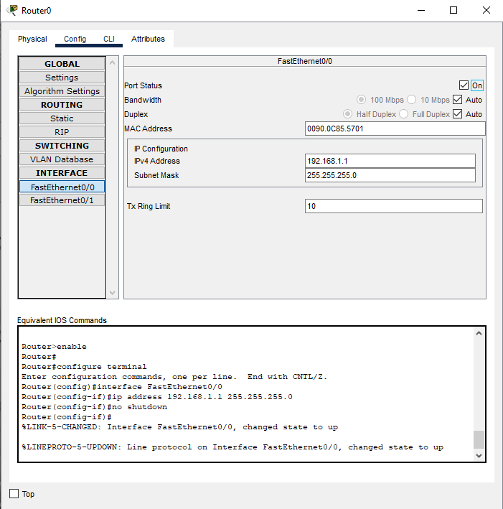

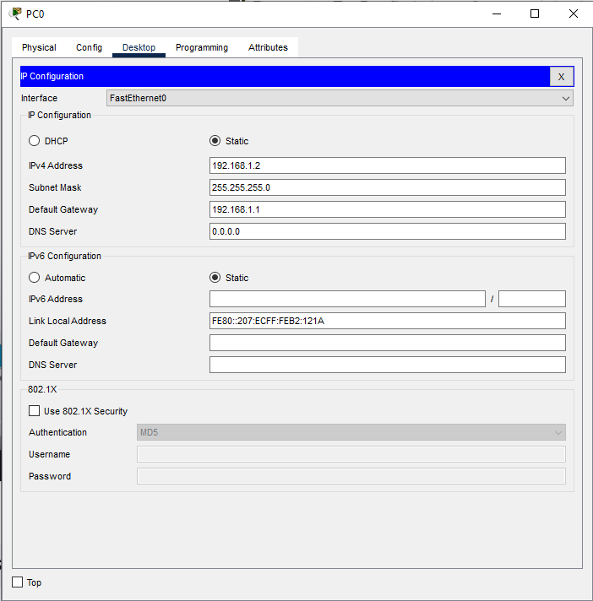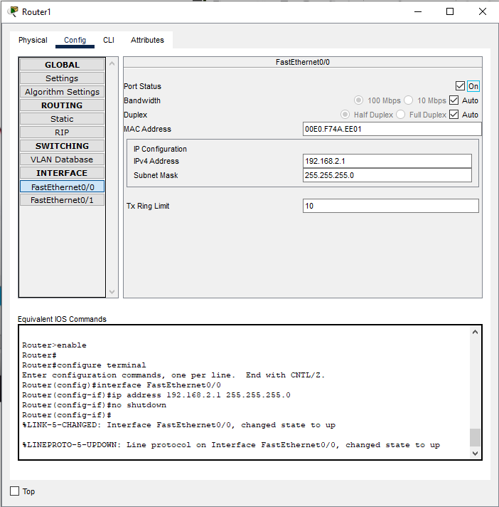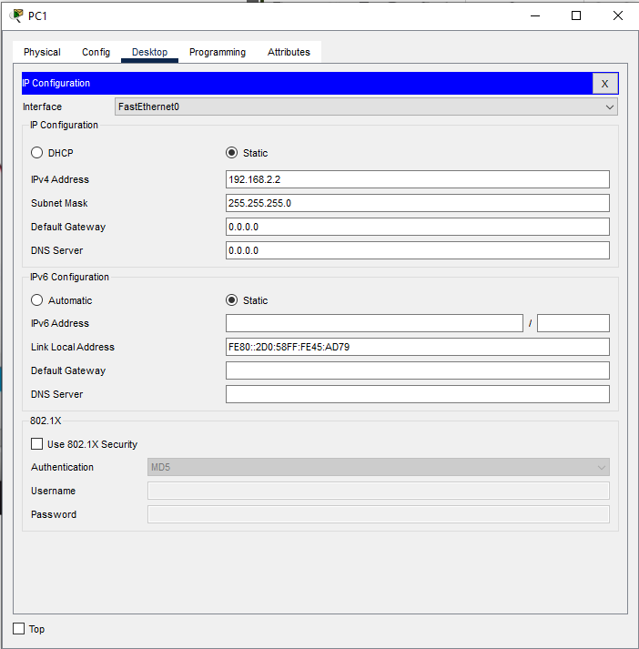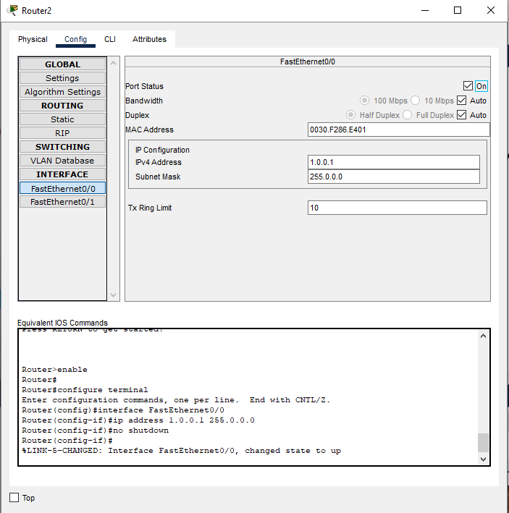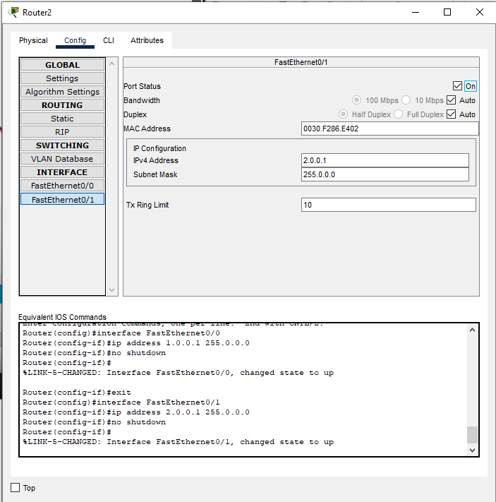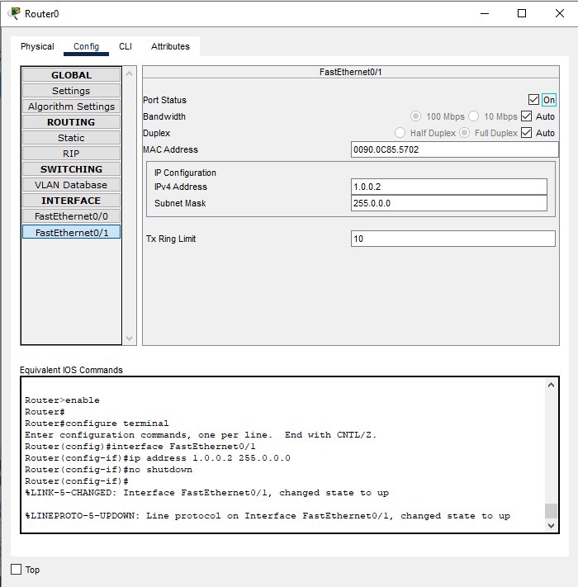

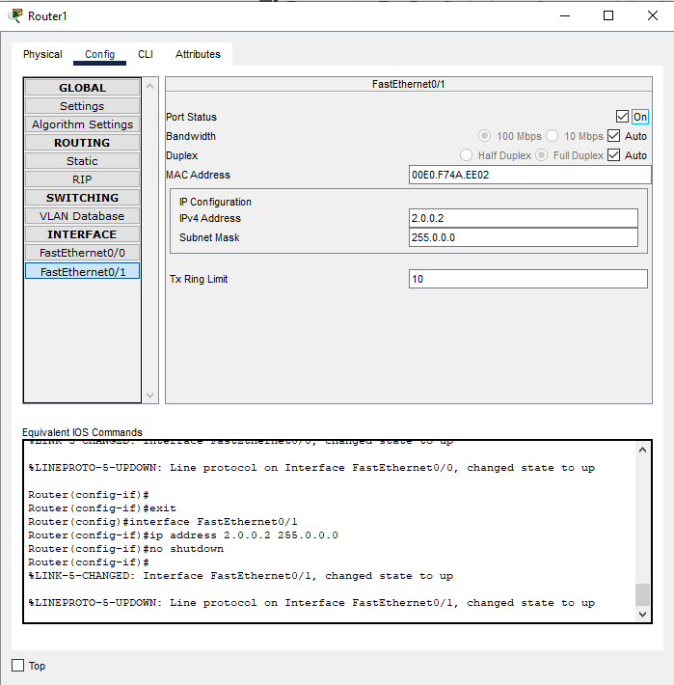

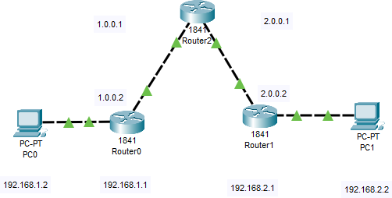

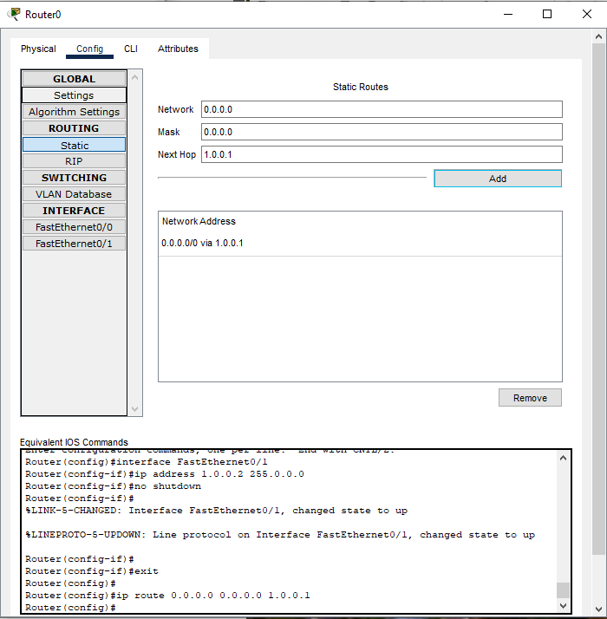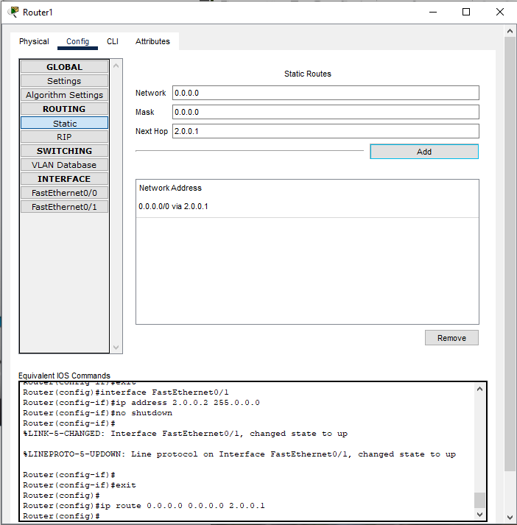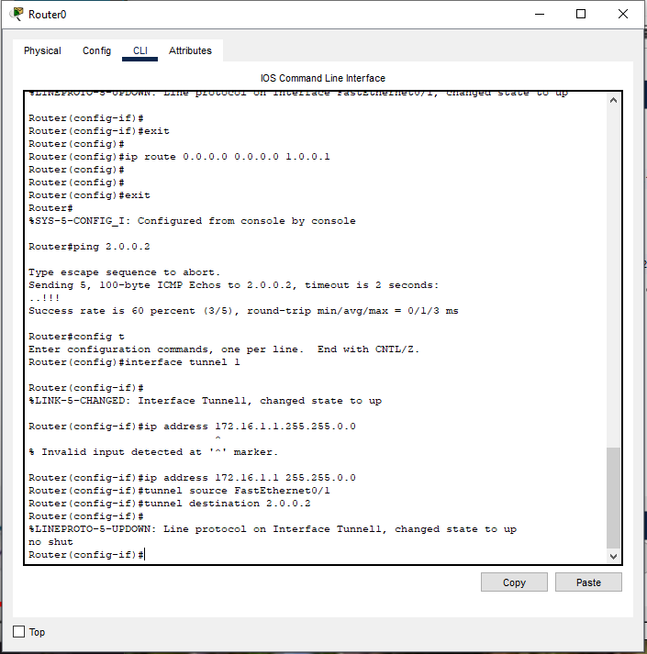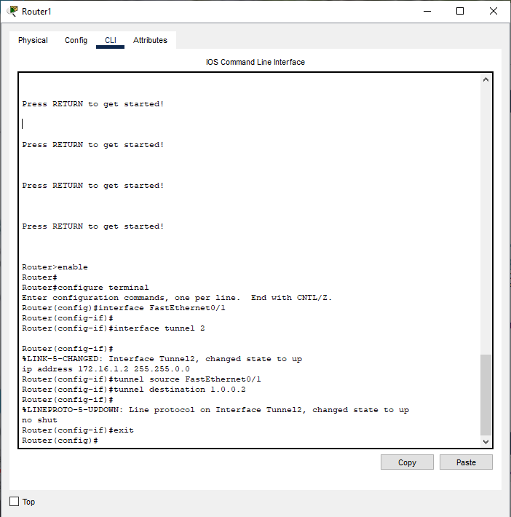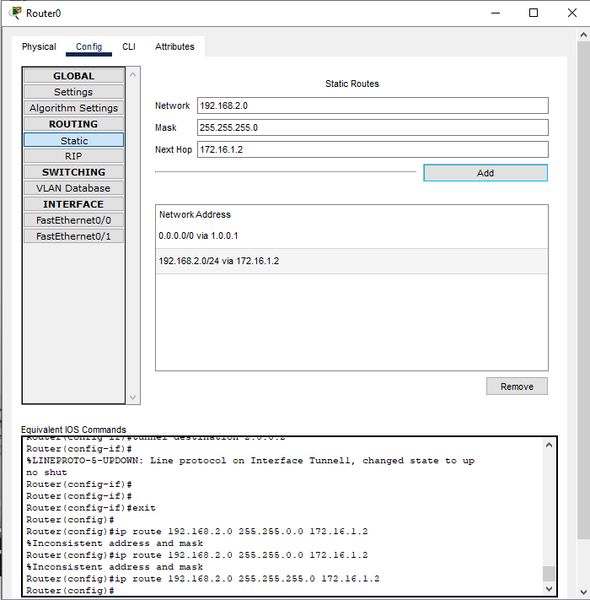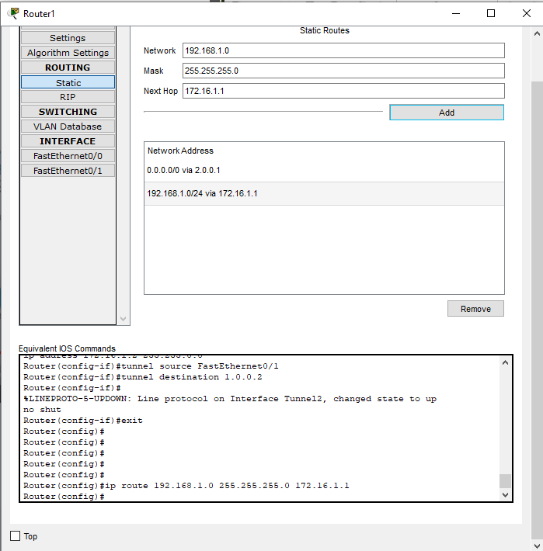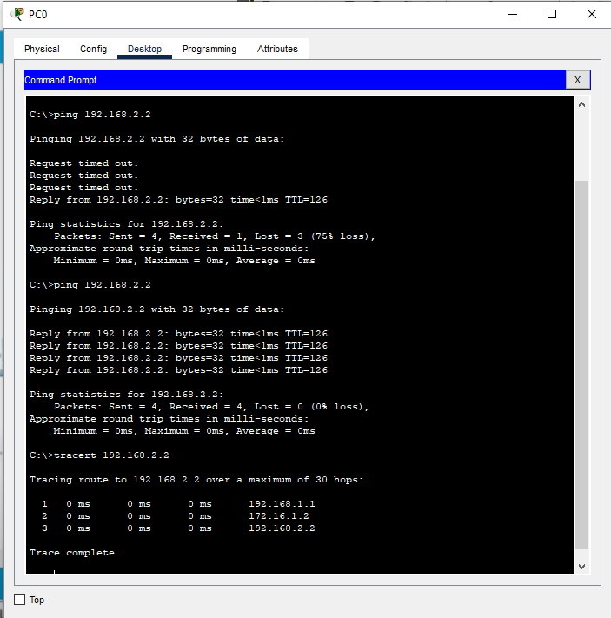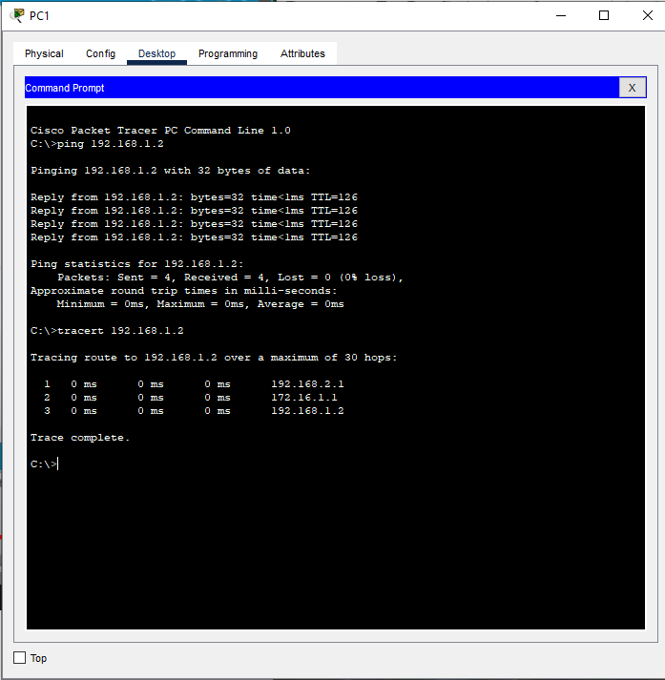

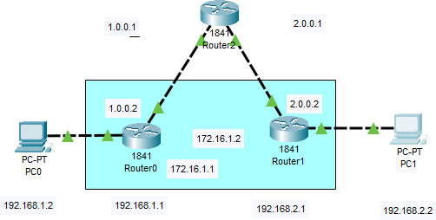

**RESULT:**

Thus , Simulation of VPN using Cisco Packet Tracer has been done successfully.

**Evaluation**

|  |  |  |
| --- | --- | --- |
| Parameter | Max Marks | Marks Obtained |
| Uniqueness of the Work | 15 |  |
| Completion of experiment on time | 10 |  |
| Documentation | 5 |  |
| Total | 30 |  |
| Signature of the faculty with Date |  |  |